Contact Manager
Ideation Phase
Empathize & Discover

Date | 07/03/2026
Team ID | 69a7d7903987a2df4043eaef
Project Name | Contact Manager
Maximum Marks | 4 Marks

Empathy Map Canvas:
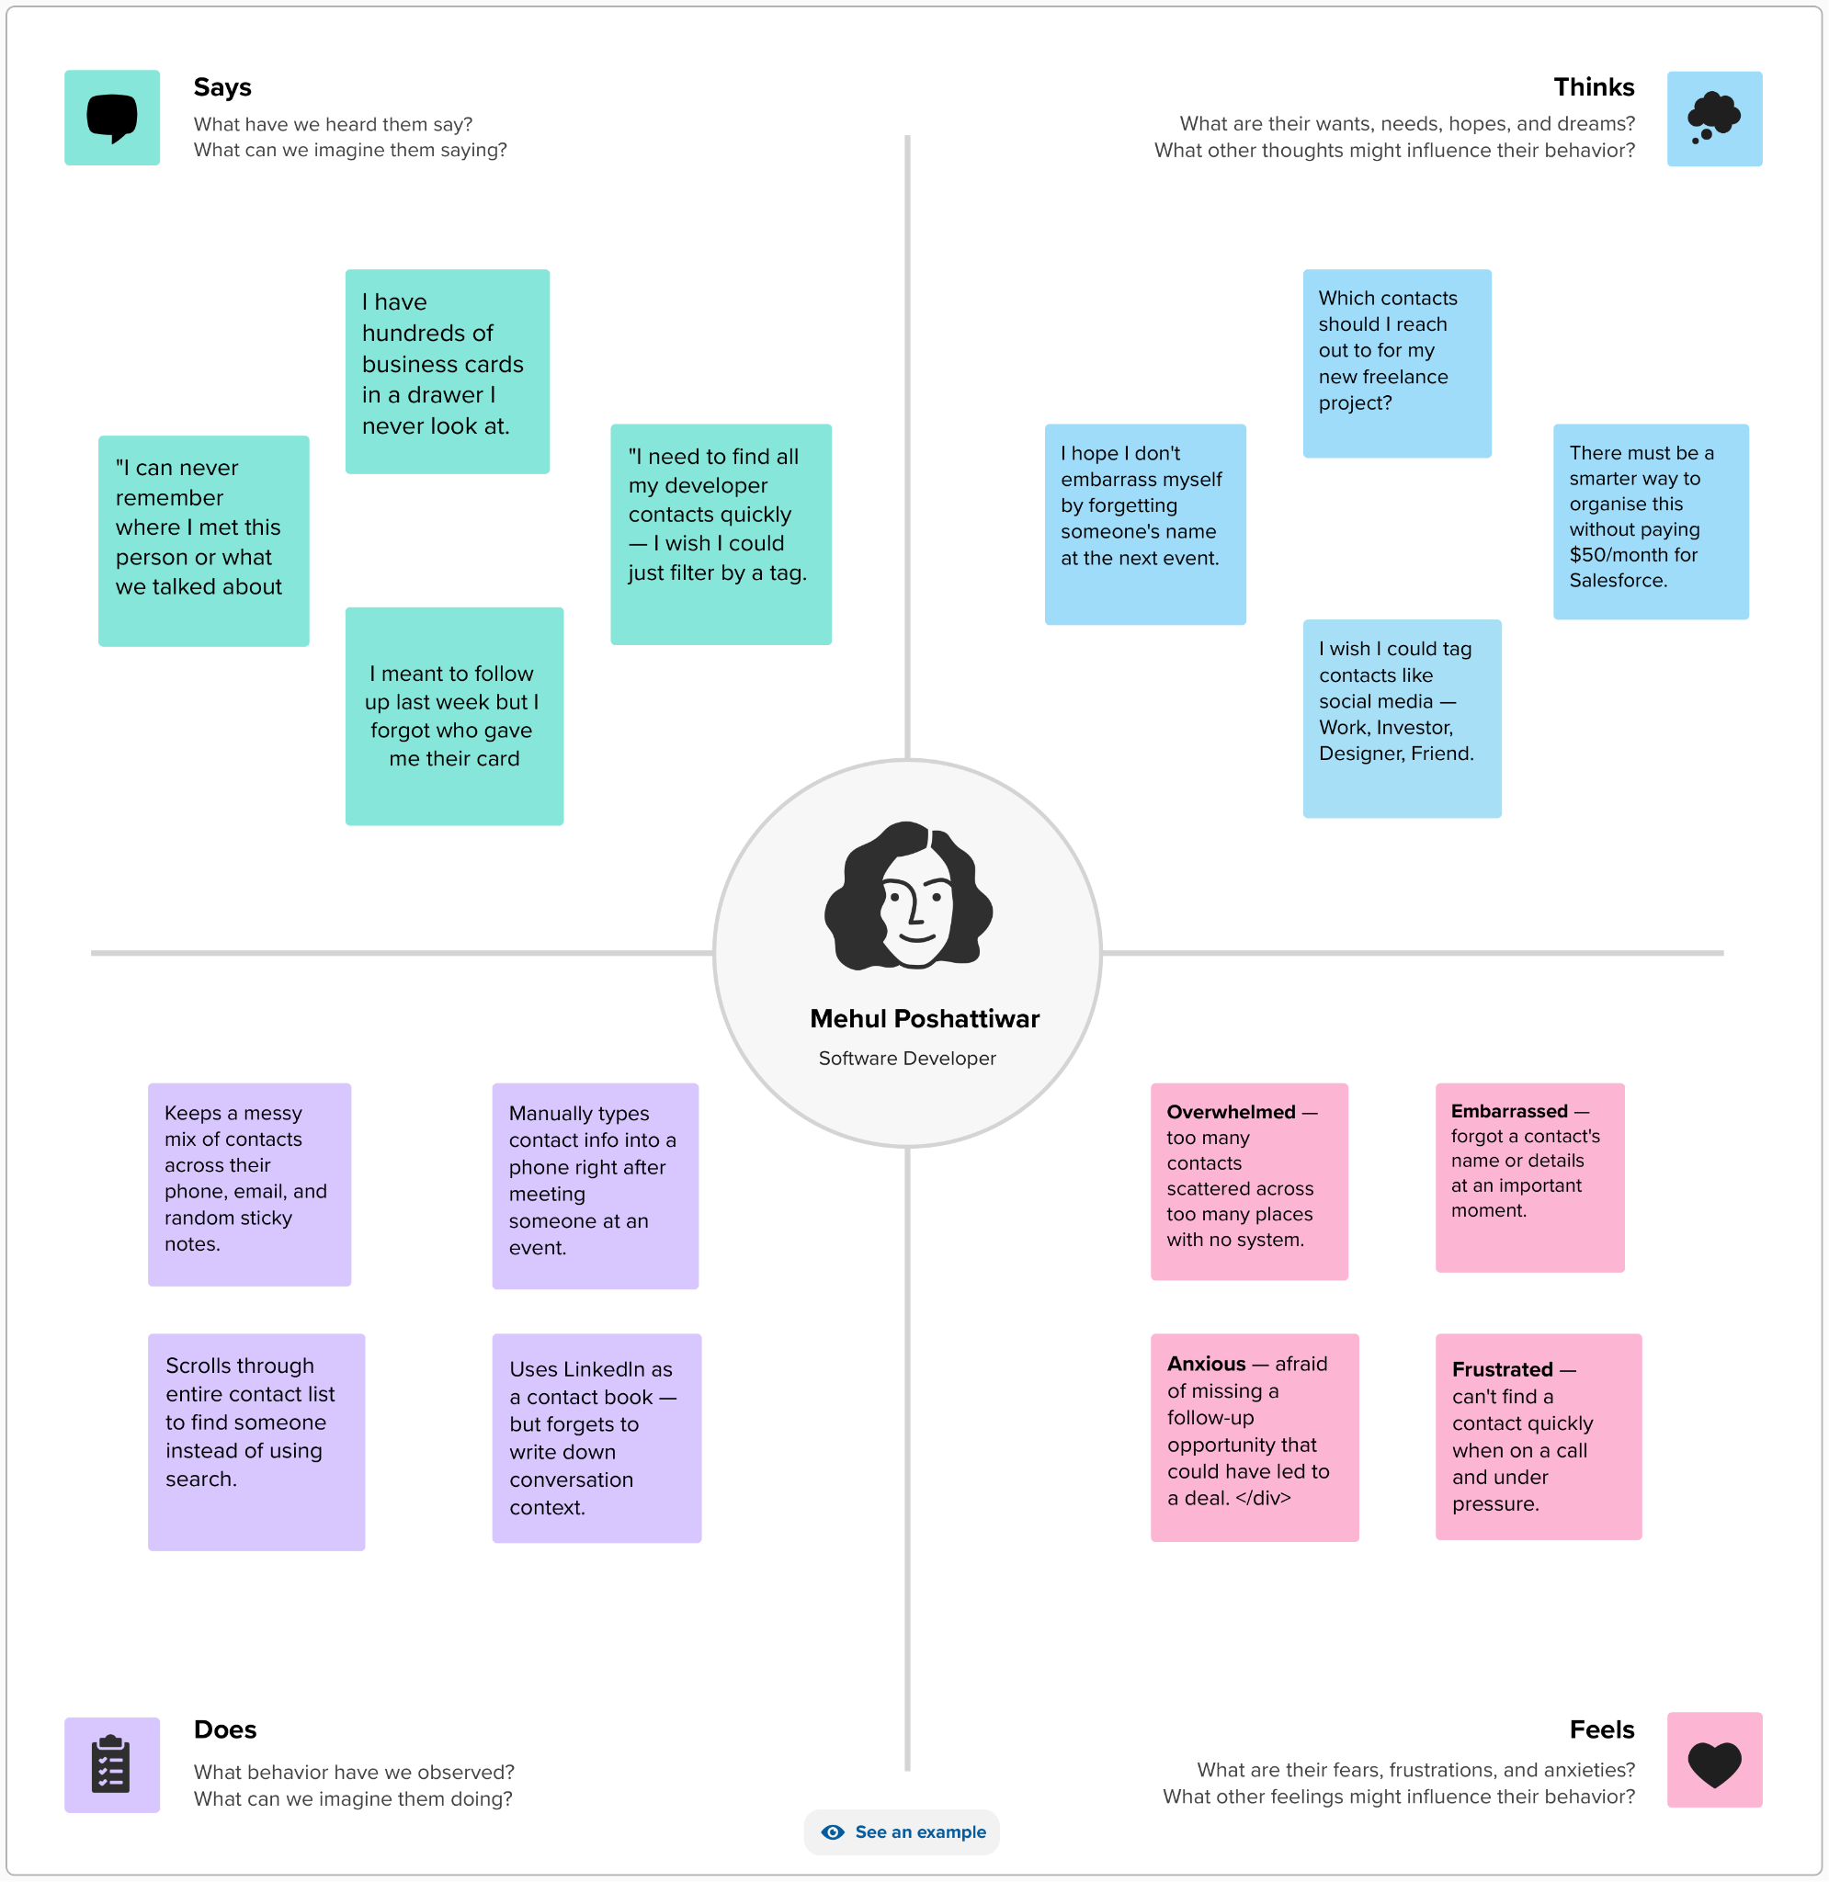

Empathize & Discover

